



Deep Learning

LAB MANUAL

Disclaimer: The content is curated from online/offline resources and used for educational purpose only
Car Price Prediction using FNN
Objective
To develop a Feedforward Neural Network (FNN) that accurately predicts car prices based on various numerical and categorical attributes such as brand, fuel type, engine size, mileage, transmission type, and more. This model will assist in understanding the influence of different features on car pricing and support better decision-making in the automotive market.
Problem Statement
Predicting the market price of a car is a complex task influenced by numerous variables. Manual estimation often lacks precision and consistency. This lab activity focuses on building a supervised machine learning model using a Feedforward Neural Network (FNN) to learn from historical car data and estimate car prices. The task involves loading and preprocessing a dataset with both numerical and categorical features, encoding categorical variables, normalizing input values, and training the FNN. The model's performance is evaluated using appropriate regression metrics (MAE, MSE, RMSE, R²). The ultimate goal is to deliver a model that predicts car prices with high accuracy, aiding buyers, sellers, and dealers in price estimation and market analysis.
Equipment Required
- Python installed with Jupyter Notebook / VS Code / Google Colab
- Libraries: pandas, numpy, matplotlib, seaborn, scikit-learn, tensorflow (Keras)
Prerequisites
- Basic knowledge of Python and pandas
- Understanding of neural networks, TensorFlow, and Keras
- Familiarity with model training, validation, and evaluation metrics
Dataset Description
The dataset used is CarPrice_dataset.csv, containing 205 records and 26 columns describing car specifications (e.g., wheelbase, engine size, horsepower, fuel economy) along with the target variable, price. The dataset contains no missing values, but the CarName column requires cleaning as it mixes brand names with model names and contains several spelling inconsistencies (e.g., 'maxda' instead of 'mazda').

Procedure
Step 1: Data Loading
Import the required libraries and load the dataset into a pandas DataFrame. Inspect its shape, structure, and data types before proceeding.
# Import required libraries
import pandas as pd
import numpy as np
import matplotlib.pyplot as plt
import seaborn as sns

# Load the dataset
df = pd.read_csv("CarPrice_dataset.csv")

# Display basic information about the dataset
print("Shape of dataset:", df.shape)
print("\nFirst 5 rows:")
print(df.head())
print("\nDataset info:")
print(df.info())

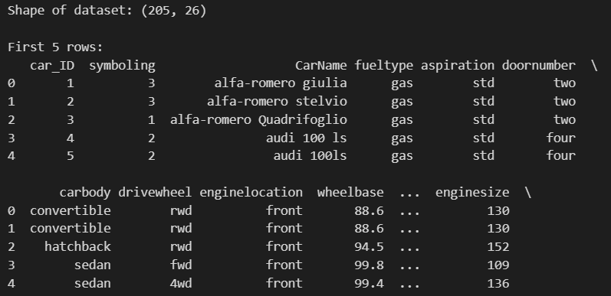
Step 2: Data Cleaning
Check for missing values and duplicates, remove the non-predictive identifier column, and clean the CarName column so that brand names are consistent and usable as a categorical feature.
# Check for missing values in each column
print("Missing values per column:\n", df.isnull().sum())

# Drop 'car_ID' - it is only a row identifier and has no predictive value
df = df.drop('car_ID', axis=1)

# Extract the car brand (first word of CarName) and standardize its case
df['CarName'] = df['CarName'].apply(lambda x: x.split(' ')[0].lower())

# Fix known spelling inconsistencies present in the raw dataset
df['CarName'] = df['CarName'].replace({
'maxda': 'mazda',
'porcshce': 'porsche',
'toyouta': 'toyota',
'vokswagen': 'volkswagen',
'vw': 'volkswagen'
})

# Check for and remove duplicate rows, if any
print("\nDuplicate rows:", df.duplicated().sum())
df = df.drop_duplicates()

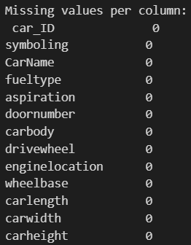

Step 3: Data Preprocessing and Train-Test Split
Separate categorical and numerical columns, one-hot encode the categorical features, split the data into training and testing sets, and scale the numerical inputs so the network trains efficiently.
from sklearn.model_selection import train_test_split
from sklearn.preprocessing import StandardScaler

# Identify categorical and numerical columns
categorical_cols = df.select_dtypes(include='object').columns.tolist()
numerical_cols = df.select_dtypes(include=['int64', 'float64']).columns.tolist()
numerical_cols.remove('price') # 'price' is the target, not a feature

print("Categorical columns:", categorical_cols)
print("Numerical columns:", numerical_cols)

# One-hot encode categorical variables (drop_first avoids the dummy-variable trap)
df_encoded = pd.get_dummies(df, columns=categorical_cols, drop_first=True)

# Separate features (X) and target (y)
X = df_encoded.drop('price', axis=1)
y = df_encoded['price']

# Split into training (80%) and testing (20%) sets
X_train, X_test, y_train, y_test = train_test_split(
X, y, test_size=0.2, random_state=42
)

# Scale features to comparable ranges - fit only on training data to avoid leaking information from the test set
scaler = StandardScaler()
X_train_scaled = scaler.fit_transform(X_train)
X_test_scaled = scaler.transform(X_test)

print("Training set shape:", X_train_scaled.shape)
print("Testing set shape:", X_test_scaled.shape)

Step 4: Building the Model
Construct a Feedforward Neural Network with dropout layers to reduce overfitting, and compile it for a regression task.
import tensorflow as tf
from tensorflow.keras.models import Sequential
from tensorflow.keras.layers import Dense, Dropout

# Build a Feedforward Neural Network (FNN)
model = Sequential([
Dense(128, activation='relu', input_shape=(X_train_scaled.shape[1],)),
Dropout(0.2), # helps prevent overfitting
Dense(64, activation='relu'),
Dropout(0.2),
Dense(32, activation='relu'),
Dense(1) # single output neuron for price (regression)
])

# Compile with Adam optimizer and MSE loss - appropriate for regression
model.compile(optimizer='adam', loss='mse', metrics=['mae'])

# Display the model architecture and parameter count
model.summary()

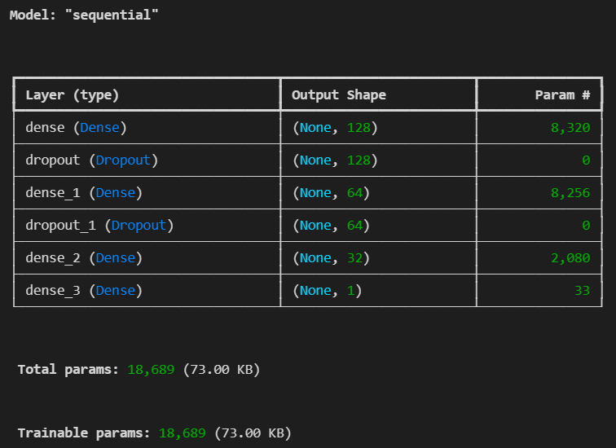
Step 5: Training the Model
Train the model using a validation split, applying early stopping to prevent overfitting and restore the best-performing weights.
from tensorflow.keras.callbacks import EarlyStopping
# Stop training if validation loss does not improve for 10 consecutive epochs, and roll back to the best weights observed
early_stop = EarlyStopping(monitor='val_loss', patience=10, restore_best_weights=True)

history = model.fit(
X_train_scaled, y_train,
validation_split=0.2,
epochs=200,
batch_size=16,
callbacks=[early_stop],
verbose=1
)

# Visualize training vs validation loss to check for overfitting/underfitting
plt.figure(figsize=(8, 5))
plt.plot(history.history['loss'], label='Training Loss')
plt.plot(history.history['val_loss'], label='Validation Loss')
plt.xlabel('Epoch')
plt.ylabel('Loss (MSE)')
plt.title('Training vs Validation Loss')
plt.legend()
plt.show()

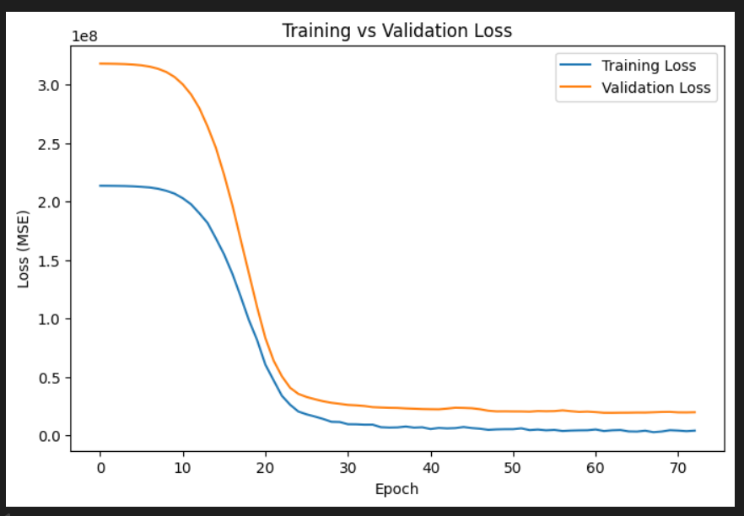
Step 6: Model Evaluation
Evaluate the trained model on the held-out test set using standard regression metrics, and visualize predicted prices against actual prices.
from sklearn.metrics import mean_absolute_error, mean_squared_error, r2_score

# Generate predictions on the test set
y_pred = model.predict(X_test_scaled).flatten()

# Compute regression evaluation metrics
mae = mean_absolute_error(y_test, y_pred)
mse = mean_squared_error(y_test, y_pred)
rmse = np.sqrt(mse)
r2 = r2_score(y_test, y_pred)
print(f"Mean Absolute Error (MAE): {mae:.2f}")
print(f"Mean Squared Error (MSE): {mse:.2f}")
print(f"Root Mean Squared Error (RMSE): {rmse:.2f}")
print(f"R-squared (R2) Score: {r2:.4f}")

# Plot actual vs predicted prices - points closer to the diagonal line
# indicate more accurate predictions
plt.figure(figsize=(8, 6))
plt.scatter(y_test, y_pred, alpha=0.6, edgecolors='k')
plt.plot([y_test.min(), y_test.max()], [y_test.min(), y_test.max()], 'r--', lw=2)
plt.xlabel('Actual Price')
plt.ylabel('Predicted Price')
plt.title('Actual vs Predicted Car Prices')
plt.show()

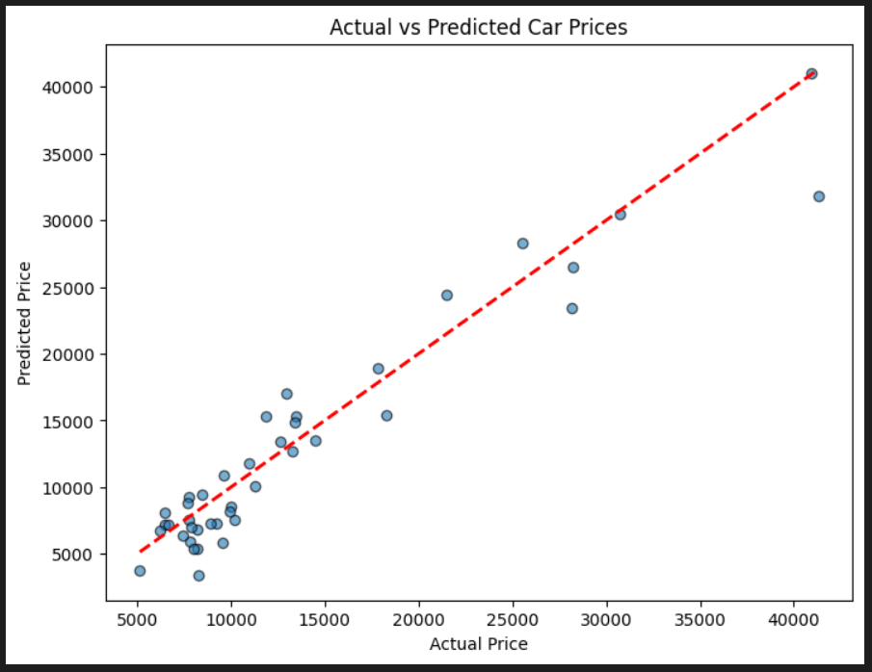
Step 7: Prediction on New Data
Demonstrate how the trained model can be used to predict the price of a new, unseen car record. Any new input must pass through the same encoding and scaling steps used during training.
# Example: use a row from the test set as a stand-in for a "new" car record
# In practice, replace this with new data built through the same cleaning and one-hot encoding pipeline used in Steps 2-3
new_data = X_test.iloc[[0]]
new_data_scaled = scaler.transform(new_data)
predicted_price = model.predict(new_data_scaled)
print(f"Predicted Price for the sample car: ${predicted_price[0][0]:,.2f}")
print(f"Actual Price for reference: ${y_test.iloc[0]:,.2f}")
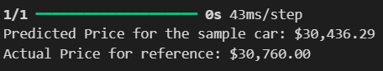
Conclusion
In this lab, a Feedforward Neural Network was successfully built to predict car prices using both numerical and categorical features. The workflow covered essential machine learning steps: data loading, cleaning (handling identifier removal, text normalization, and inconsistent brand names), categorical encoding, feature scaling, and train-test splitting. A multi-layer FNN with dropout regularization was trained using early stopping to prevent overfitting, and its performance was assessed using MAE, MSE, RMSE, and R² metrics. The model demonstrated the ability to capture the non-linear relationships between car attributes and price, and the same pipeline can be reused to predict prices for new, unseen car listings after applying identical preprocessing steps.

